Dementia Bulletin  February - March 2019 | 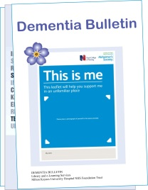

This bulletin gathers reports, guidelines and articles indexed in KnowledgeShare, as well as any books newly purchased for the Library.

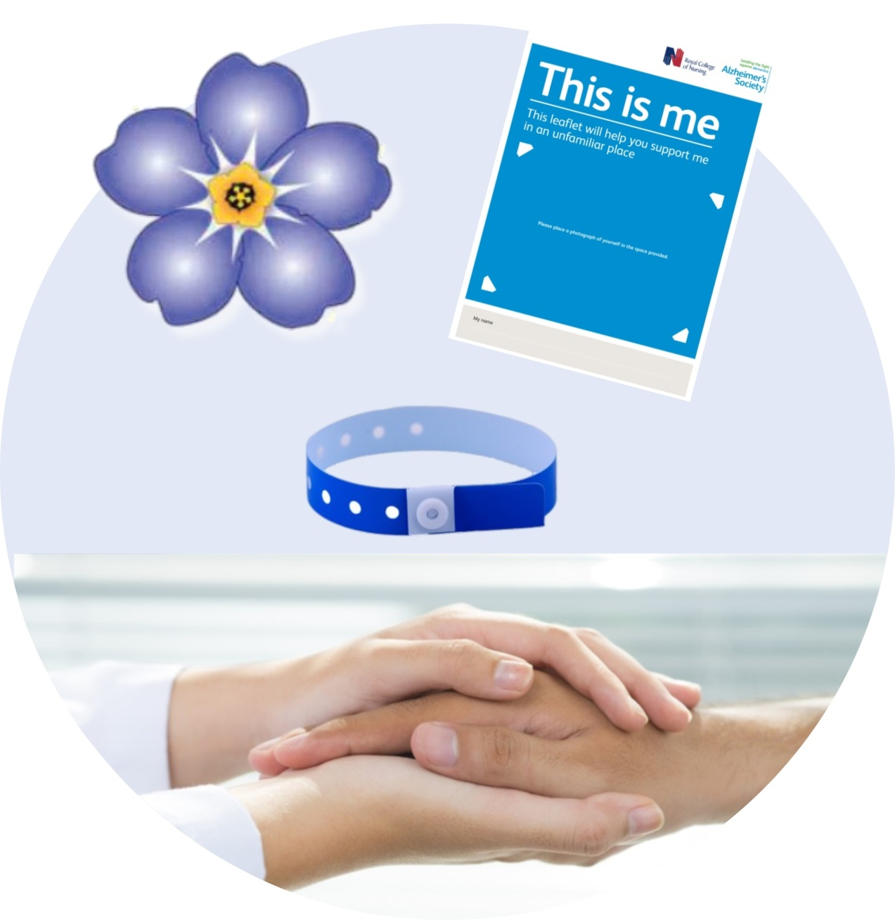

Bulletin produced by Milton Keynes University Hospital Library
library@mkuh.nhs.uk | T: 01908 995061 | Internal: 85061 | Intranet > Library | 

Articles

A systematic literature review and meta-analysis of real-world interventions for cognitive ageing in healthy older adults.
Vaportzis E. Ageing Research Reviews 2019;50:110-130.
Our review included 43 studies with real-world activities as potential interventions. Analyses revealed cognitive benefits primarily from physical activity interventions. Cognitive activity interventions were less effective in improving cognitive function.
Available with your NHS OpenAthens username and password
Gabapentin and pregabalin to treat aggressivity in dementia: a systematic review and illustrative case report.
Supasitthumrong T. British Journal of Clinical Pharmacology 2019;:doi.org/10.1111/bcp.13844.
Gabapentin and pregabalin could be considered for BPSD when medications having stronger evidence bases (risperidone, other antipsychotics, carbamazepine and citalopram) have been ineffective or present unacceptable risks of adverse outcomes.
Freely available online
Psychosocial interventions for pain management in older adults with dementia: A systematic review of randomized controlled trials.
Pu L. Journal of Advanced Nursing 2018;:doi: 10.1111/jan.13929.
Findings suggest that psychosocial interventions may be potentially effective alternatives for pain management in people with dementia. However, caution is needed in interpreting these results due to limited studies, risk of bias and heterogeneity across studies.
Please contact the library for a copy of this article
Wandering behaviour and elopement in the nursing home.
Duffy A. British Journal of Healthcare Assistants 2019;13(1):23 - 30.
This article explores the challenges encountered and provides solutions for care staff to better manage wandering behaviour in residents in long-term care settings.
Available in print at the library

Books

The following books have been recently added to the library’s collection and are available to borrow. The library has a wide selection of books on dementia.

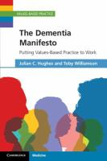 | Hughes, J.C. and Williamson, T.  The dementia manifesto: putting values-based practice to work.  Cambridge: Cambridge University Press, 2019  WM 221 HUG
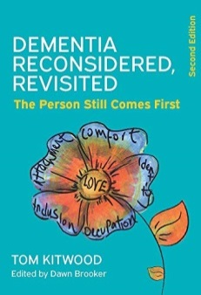 | Kitwood, T. and Brooker, D.  Dementia reconsidered, revisited: the person still comes first. 2nd ed.  London: Open University Press, 2019  WM 224 KIT
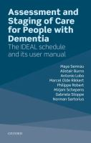 | Semrau, M., et al.  Assessment and staging of care for people with dementia: the IDEAL schedule and its user manual.  Oxford: Oxford University Press, 2019  WM 221 SEM

Reports
Articles
Exploring dementia and agitation: How public policy needs to respond.
International Longevity Centre – UK (ILC-UK); 2019.
https://ilcuk.org.uk/exploring-dementia-and-agitation-how-public-policy-needs-to-respond/
With 850,000 people living with dementia in the UK, there is a significant need to understand how to improve the quality of life for them and their carers. This report summarises a number of key findings from the MARQUE (Managing Agitation and Raising Quality of Life in Dementia) project, led by Professor Gill Livingston from UCL. MARQUE is the largest-ever study involving people living in care homes.
Freely available online
Sleep problems in dementia: a promising treatment?
The Mental Elf; 2019.
https://www.nationalelfservice.net/mental-health/dementia/sleep-dementia-promising-treatment/
A group of UCL Masters Students summarise the DREAMS-START trial (Dementia RElAted Manual for Sleep; STrAtegies for RelaTives), which looks at the feasibility and acceptability of a simple 6 session intervention delivered by psychology graduates for people with dementia and their carers affected by sleep disturbances.
Freely available online

Behind the Headlines

'Small' increase in risk of Alzheimer's disease with HRT use, study suggests.
NHS Behind the Headlines; 2019.
https://www.nhs.uk/news/medication/small-increase-risk-alzheimers-disease-hrt-use-study-suggests/
A study identified all postmenopausal women in Finland who'd been diagnosed with Alzheimer's disease over a 14-year period. It compared their use of HRT (hormone replacement therapy) with a group of postmenopausal women without the disease. Researchers found that those with Alzheimer's were slightly more likely to have used HRT pills or patches than women without Alzheimer's.
Freely available online

Eye test can pick up Alzheimer's, study claims.
NHS Behind the Headlines; 2019.
https://www.nhs.uk/news/neurology/eye-test-can-pick-alzheimers-study-claims/
A new study has found that people with Alzheimer's had fewer blood vessels and less blood flow in the retina (back of their eye). The Alzheimer-linked eye changes were detected by an eye test that uses a scanning technique called Octa (optical coherence tomography angiography). This is very early research. It's too soon to say that it will lead to a simple test for Alzheimer's.
Freely available online

NHS OpenAthens - Self-register at https://openathens.nice.org.uk/
You will need your own NHS OpenAthens account to access some of the articles in this bulletin. Select Milton Keynes University Hospital NHS Foundation Trust as your organisation. Your username will be generated after you submit the online registration form. Look out for an automated email from ‘OpenAthens’ in your Inbox; click on the activation link to set your password.

Please email library@mkuh.nhs.uk if you would like help with accessing any of the items signposted in this bulletin. If you require further information on a specific topic, do get in touch.

We’re happy to help you with literature searches, search skills training and advice, keeping you up to date, and general references enquiries.

To subscribe/unsubscribe from this bulletin please email library@mkuh.nhs.uk or reply to this email.
Our privacy notice is available at https://intranet.mkuh.nhs.uk/gdpr.
Milton Keynes University Hospital Library and e-Learning Services
library@mkuh.nhs.uk | T: 01908 995061 | Internal: 85061 | Intranet > Library

